Abstract— The Olympic sports Fencing bouts are very fast; infact, in Saber Fencing, the difference between touches could be less than 100ms, and there are complex rules of Right of Way [1]. That's where the role of the referee is essential. As the fencing community is very small, often, in most of the local and regional tournaments, it isn't easy to get experienced referees. This study aims to use Artificial intelligence (AI) as referee assist technology to improve the quality of refereeing. The study explores using the Computer Vision Machine Learning Technique using Convolution Neural Network (CNN) to decide the touch direction. The study demonstrated that the Machine Learning classification approach shows a successful outcome in most of the fencing attacks. This would help tremendously as the referee assists technology.
Evaluation of the Use of Computer Vision Machine Learning as Referee Assist Technology to Increase the Accuracy of Results
Asmi Sawant.

Introduction
Fencing is among the fastest and most challenging sports because the bouts are often short. As discussed in [2], the minimum Work Time (WT) for the Saber Fencer could be 49 seconds for the 15 touches bout, with an Average Allez Time by bout (AAT) less than 2 seconds in the saber fencing and the time difference between the touches of the opponents could be less than 100ms. This frequently creates a unique challenge for the referees; it could be about how the referee sees it based on the position, distance, and interpretation in mind. This could influence the outcome of a bout. Additionally, there are complex rules about the Right of way, as discussed in [1] and [3], which decide which of the fencers scores a point. In addition to these complexities, the fencing community is very small, and fencing referees are an even further smaller community. Most of the fencing tournaments are at least 10 hours/day tournaments spread over 2-3 days with events divided by multiple age groups, two genders, and 3 weapons, which puts the referee under tremendous physical pressure combined with the mental stress of concentration during AAT, interpreting the touch and offering a point to fencer could lead to mental fatigue.

This study evaluated computer vision (CV) and machine learning (ML) classification. This is 1st formal research study of the use of AI, comparing it with actual human referees and then analyzing the results. Previously, there was a similar effort by Jason Mo [4], which explored the novel use of the CV and ML; however, the main focus of the exploration of commercialization for helping the spectators understand the results and doesn’t provide any evidence of analysis of the accuracy of the results, and whether the technology can be used as referee assist technology to improve the results during the bout.

Methods
With any Artificial Intelligence (AI) model, the ML datasets are essential for two key factors:
- It allows for training the ML model and
- It provides a benchmark for measuring the accuracy of the model.
This will improve the overall decision quality. Fortunately, we are blessed with a large video of the fencing library on YouTube.
- FencingVision is one of the channels on YouTube, with over 21K high-quality fencing matches organized properly with events, weapons, and gender playlists.
- Then, we saved the playlist of a particular saber fencing event in the text file.
For this evaluation, we decided to focus only on the Saber method. The main reason for this is, as mentioned in [2], Saber has the lowest AAT – less than 2 seconds – vs Foil – around 6 seconds – and Epee is the longest – about 18 seconds. So, the Saber is the fastest of the three weapons. Additionally, in the Saber, the touch is scored by thrust and cutting, while the other two weapons use only thrust [1]. Also, the right of way in the Saber and Foil has more complex rules for the right of way than in the Epee. So, it is hypothesized that once the model works for the Saber, it would be easy to adopt the model for the other two weapons, except there may be a need to adjust for the more straightforward right-of-way rules.

All further steps were developed in Python using Google Research’s web-based Colab tool, which is well-suited for ML, data analysis, and education.
- The text file in step 2 above was used to download the videos using PyTube.
- The Videos in the playlist were cut into short 3-second – a longer time than AAT for Saber – so that all the relevant action around the touch can be captured.
- Based on the relevant action, Right Fencer Point, Left Fencer Point, or Simultaneous Touch were saved in specific folders.
- The above process was repeated through various diff saber playlists to create ~1700 small clips worth 1.7GB.
- Each of these small files was saved with the following naming convention – A-BCC-DD,mp4, where
A: Type of Weapon – Saber (S), Foil (F), Epee (E).
B: Left (L), Right (R), Simultaneous (S) Touch
CC: Number of Videos in a particular playlist.
DD: Number of touches in a particular CC
Example: S-L12-24mp4 means Saber Fencing, Left Touch, 12th Video in a playlist, 24 touch in the 12th Video.
This step took almost 15 hours.
- For these Videos, the video classification model was built, the model was trained, and then it was evaluated using the steps described by Aarohi [5] – mainly features extraction using Convolution Neural Network (CNN), Sequencing the model using Recurrent Neural Network (RNN), and then, Training the model and Inferencing with new short video clips.
- Based on the model, the videos were labeled as FencingA-BCC-DD,mp4, where
A: Type of Weapon – Saber (S), Foil (F), Epee (E).
B: Left (L), Right (R), Simultaneous (S) Touch
CC: Number of Videos in a particular playlist.
DD: Number of touches in a particular CC
Example: FencingS-L12-24mp4 means Saber Fencing, Left Touch, 12th Video in a playlist, 24 touch in the 12th Video.
This step took almost 48 hours.
- The qualified human fencing referee manually observed the classified video by the inferencing model in step 6 in slow motion and made a human decision on the fencing touch.
Observing these 350 videos manually took almost 2-weeks to decide- the manual referee decision and the ML model video classification.

The above steps can be modeled using the Machine Learning pipeline, as shown in Figure 1.
The results of the above program are shared in the next section, along with a discussion.

- Heat Transfer Through Clothing (Reused from [3])
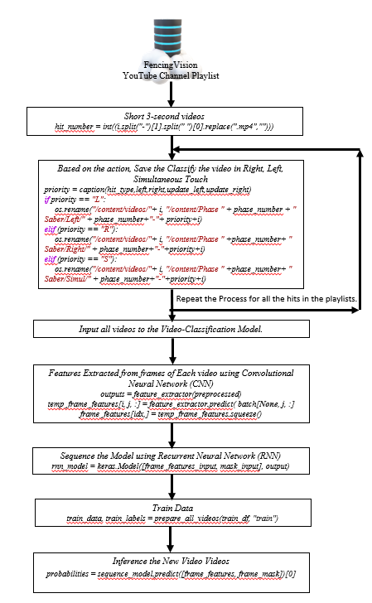

Results And Discussion
We prepared a spreadsheet with all the videos classified by the model as Left, Right, and Simultaneous, and then, a qualified human fencing referee observed all those videos and decided his judgment whether the referee felt it right, left, or simultaneous touches. We observed the following distribution as shown in Table I. The 1st column has details of ML-based Video classification distribution. The other 3 columns show the distribution of the same video when observed by a human referee.
- Comparison of ML CLassified Video Touch vs. human referee classification for SABER
ML-based Video Classification | Human Referee classification
ML-based Video Classification | Left | Right | Simultaneous
Left: 160 Videos | 112 Videos  (~70 %) | 17 Videos  (~10%) | 31 Videos  (~20%)
Right: 170 Videos | 20 Videos  (~11%) | 126 Videos  (~75%) | 24 Videos  (~14%)
Simultaneous: 20 Videos | 5 Videos  (~25%) | 7 Videos  (~35%) | 8 Videos  (~40%)

Based on Table I, as well as by observing the video clips, we found the following pattern:
- The ML Model classified the video with at least 70% accuracy compared to humans. Infact, it was noted that the model classified all the attacks correctly. One of the main reasons for comparatively higher accuracy is the large number of datasets used for training – almost 1700 videos.
- When the results didn't match for the remaining 30%, we analyzed the results and found significant discrepancies. We noticed that the ML model didn’t detect parry-riposte [1]. The blade maneuvering is one of the main reasons the ML model fails during the parry-riposte. The model is not able to classify the parry-riposte.
- Additionally, we noticed that the model couldn’t pick up any yellow card faults due to crossing legs while moving forward.
Based on the work completed by Jason [4], where OpenPose Estimation was used for the classification, we believe it will also have challenges to detect the parry-riposte in fencing, as OpenPose Estimation work only on the human body and is not able to apply on the fencing blade, so, it would not detect the blade maneuvering.

Conclusion
As discussed throughout the paper, the fencing referees must make decisions quickly based on interpreting sequence events within less than 100 msec, and doing such for a 10hours/day is mentally challenging. Since in fencing, the referee makes all the points calls; it is necessary to develop a more automated referee assist technology. The Computer Vision Machine Learning and classification model has demonstrated that it can be the referee assist for Saber Fencing, the fastest of the 3 weapons. The approach is expected to work with Foil and Epee weapons as well; however, it is one of the future works to validate so that the method can be adapted to all 3 weapons. Further advanced ML classification, such as TensorFlow, must be explored for the parry-riposte maneuvering.
Acknowledgment
I want to thank Jason Mo, who shared his learnings in using AI in the Fencing Referee, and Aarohi for her YouTube video and the GitHub repository [5]. Also, my parents continuously guided, mentored, and challenged me throughout the research project.
References
- Fencing Essentials: Explained with Videos https://fencinginsider.com/olympic-fencing-essentials/
- Tarrago R, Bottoms L, Iglesias X (2023), “Temporal demands of elite fencing,” PLoS ONE 18(6), e0285033, . https://doi.org/10.1371/journal.pone.0285033
- The Rules of Fencing (Olympic Fencing) - EXPLAINED!, Ly Ninh, https://www.youtube.com/watch?v=x7zxpDW8nb0
- High School Student Blog: The role of AI in Fencing (Referring), 2021, Mo Jason, https://www.inspiritai.com/blogs/ai-blog/2021/9/18/student-blog-the-role-of-ai-in-fencing-refereeing
- Video Classification with a CNN-RNN Architecture | Human Activity Recognition, Aarohi, https://www.youtube.com/watch?v=ezjnySXqdTo

 Asmi Sawant is a High School Junior at Basis Independent Silicon Valley, San Jose, CA. She is a competitive Saber Fencer and is very keen on working at the intersection of technology, engineering, and humanity to improve the Quality of Life. (Email: asmi.sawant1@gmail.com)

